1989 D
The carbon isotope of mass 12 is stable. The carbon isotopes of mass 11 and mass 14 are unstable. However, the type of radioactivity decay is different for these two isotopes. Carbon-12 is not produced in either case.
(a) Identify a type of decay expected for carbon-11 and write the balanced nuclear reaction for that decay process.
(b) Identify the type of decay expected for carbon-14 and write the balanced nuclear reaction for that decay process.
(c) Gamma rays are observed during the radioactive decay of carbon-11. Why is it unnecessary to include the gamma rays in the radioactive decay equation of (a)?
(d) Explain how the amount of carbon-14 in a piece of wood can be used to determine when the tree died.

1991 D
Explain each of the following in terms of nuclear models.
(a) The mass of an atom of ⁴He is less than the sum of the masses of 2 protons, 2 neutrons, and 2 electrons.
(b) Alpha radiation penetrates a much shorter distance into a piece of material than does beta radiation of the same energy.
(c) Products from a nuclear fission of a uranium atom such as ⁹⁰Sr and ¹³⁷Ce are highly radioactive and decay by emission of beta particles.
(d) Nuclear fusion requires large amounts of energy and to get started, whereas nuclear fission can occur spontaneously, although both processes release energy.
Answer:

1997 D
Answer each of the following questions regarding radioactivity.
(a) Write the nuclear equation for decay of ²³⁴₉₄Pu by alpha emission.
(b) Account for the fact that the total mass of the products of the reaction in part (a) is slightly less than that of the original a(234, 94)Pu.
(c) Describe how α, β, and γ rays each behave when they pass through an electric field. Use the diagram below to illustrate your answer.
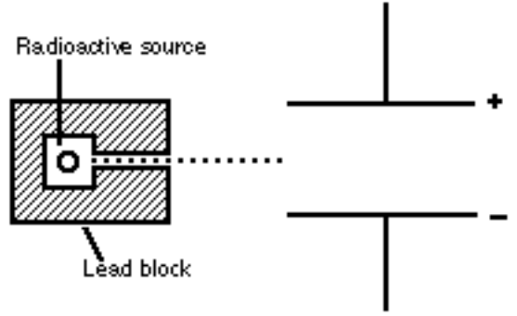
(d) Why is it not possible to eliminate the hazard of nuclear waste by the process of incineration?

